Date:08-10-2026
Program 1
Code:
#include <stdio.h>

int main()
{
int arr[100], unique[100];
int n, i, j, k = 0;
int found;

printf("Enter the number of elements: ");
scanf("%d", &n);

printf("Enter %d elements:\n", n);
for (i = 0; i < n; i++)
{
scanf("%d", &arr[i]);
}

// Find unique elements
for (i = 0; i < n; i++)
{
found = 0;

for (j = 0; j < k; j++)
{
if (arr[i] == unique[j])
{
found = 1;
break;
}
}

if (found == 0)
{
unique[k] = arr[i];
k++;
}
}

printf("Unique elements:\n");
for (i = 0; i < k; i++)
{
printf("%d ", unique[i]);
}

return 0;
}
Output:
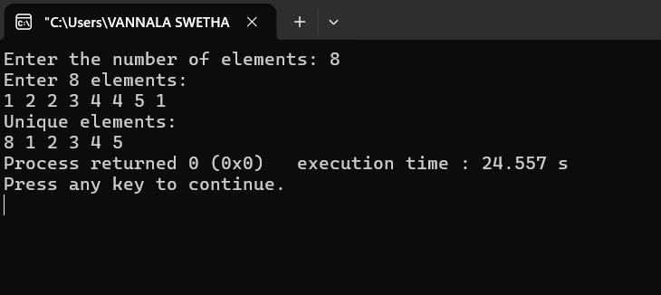

Program 2:
Code:
#include <stdio.h>

int main()
{
int arr[100], n;
int i, j, temp;

printf("Enter the number of elements: ");
scanf("%d", &n);

printf("Enter %d elements:\n", n);
for (i = 0; i < n; i++)
{
scanf("%d", &arr[i]);
}

// Bubble Sort
for (i = 0; i < n - 1; i++)
{
for (j = 0; j < n - i - 1; j++)
{
if (arr[j] > arr[j + 1])
{
temp = arr[j];
arr[j] = arr[j + 1];
arr[j + 1] = temp;
}
}
}

printf("Sorted array:\n");
for (i = 0; i < n; i++)
{
printf("%d ", arr[i]);
}

return 0;
}
Output: 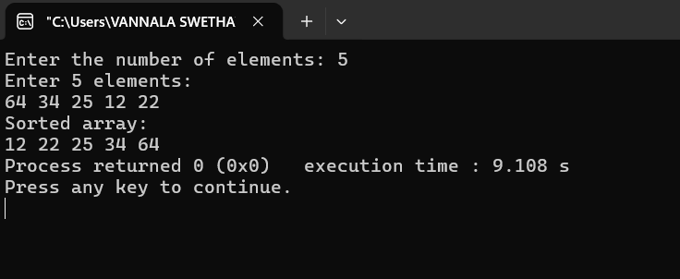

Program 3:
Code:
#include <stdio.h>

int main()
{
int arr[100], n, key;
int low, high, mid;
int found = 0;
int i;

printf("Enter the number of elements: ");
scanf("%d", &n);

printf("Enter %d elements in sorted order:\n", n);
for (i = 0; i < n; i++)
{
scanf("%d", &arr[i]);
}

printf("Enter the element to search: ");
scanf("%d", &key);

low = 0;
high = n - 1;

while (low <= high)
{
mid = low + (high - low) / 2;

if (arr[mid] == key)
{
printf("Element %d is found at position %d\n",
key, mid + 1);
found = 1;
break;
}
else if (arr[mid] < key)
{
low = mid + 1;
}
else
{
high = mid - 1;
}
}

if (found == 0)
{
printf("Element %d is not found\n", key);
}

return 0;
}
Output:
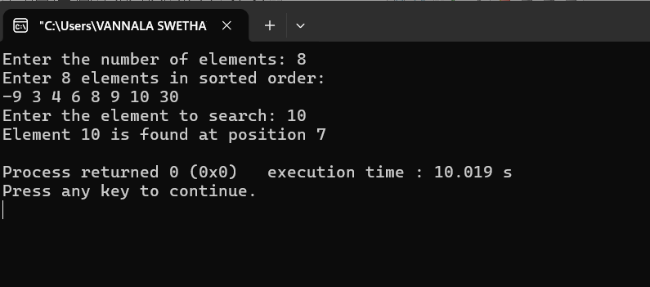

Program 4:
Code:
#include <stdio.h>

void heapify(int arr[], int n, int i)
{
int largest;
int left;
int right;
int temp;

largest = i;
left = 2 * i + 1;
right = 2 * i + 2;

// Check left child
if (left < n && arr[left] > arr[largest])
{
largest = left;
}

// Check right child
if (right < n && arr[right] > arr[largest])
{
largest = right;
}

// If largest is not the root
if (largest != i)
{
temp = arr[i];
arr[i] = arr[largest];
arr[largest] = temp;

heapify(arr, n, largest);
}
}

void heapSort(int arr[], int n)
{
int i, temp;

// Build max heap
for (i = n / 2 - 1; i >= 0; i--)
{
heapify(arr, n, i);
}

// Extract elements from heap
for (i = n - 1; i > 0; i--)
{
temp = arr[0];
arr[0] = arr[i];
arr[i] = temp;

heapify(arr, i, 0);
}
}

int main()
{
int nums[100], n, i;

printf("Enter the number of elements: ");
scanf("%d", &n);

printf("Enter %d elements:\n", n);
for (i = 0; i < n; i++)
{
scanf("%d", &nums[i]);
}

heapSort(nums, n);

printf("Sorted array in ascending order:\n");

for (i = 0; i < n; i++)
{
printf("%d ", nums[i]);
}

return 0;
}

Output:
